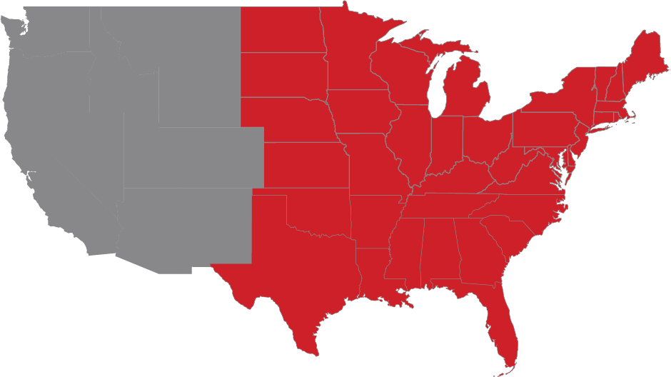
Alabama  Arkansas  Connecticut  Delaware  Florida  Georgia  Illinois  Indiana  Iowa  Kansas | Kentucky  Louisiana  Maine  Maryland  Massachusetts  Michigan  Minnesota  Mississippi  Missouri  Nebraska | New Hampshire  New Jersey  New York  North Carolina  North Dakota  Ohio  Oklahoma  Pennsylvania  Rhode Island  South Carolina | South Dakota  Tennessee  Texas  Vermont  Virginia  West Virginia  Wisconsin

